Perfect 👍 since you're working with Stripe, here are the official Stripe test cards you can safely use in test mode.
These work when your keys start with:
sk_test_
pk_test_

💳 1️⃣ Successful Payment Cards
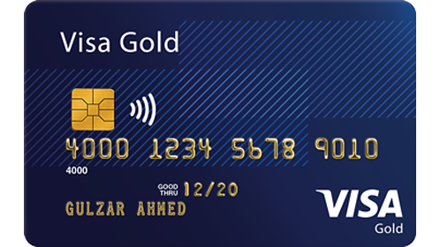
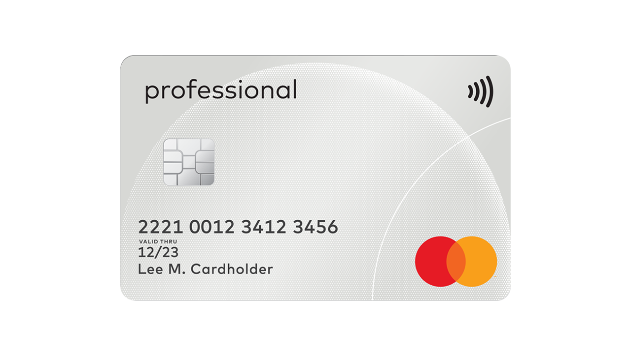
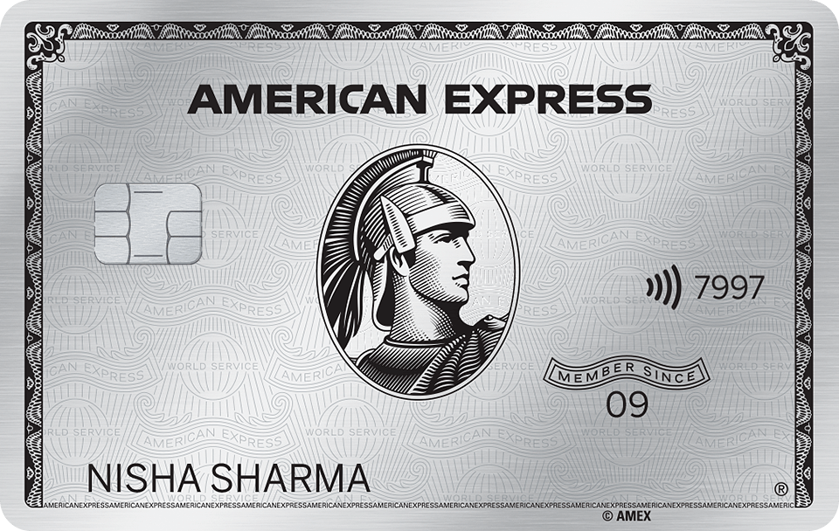
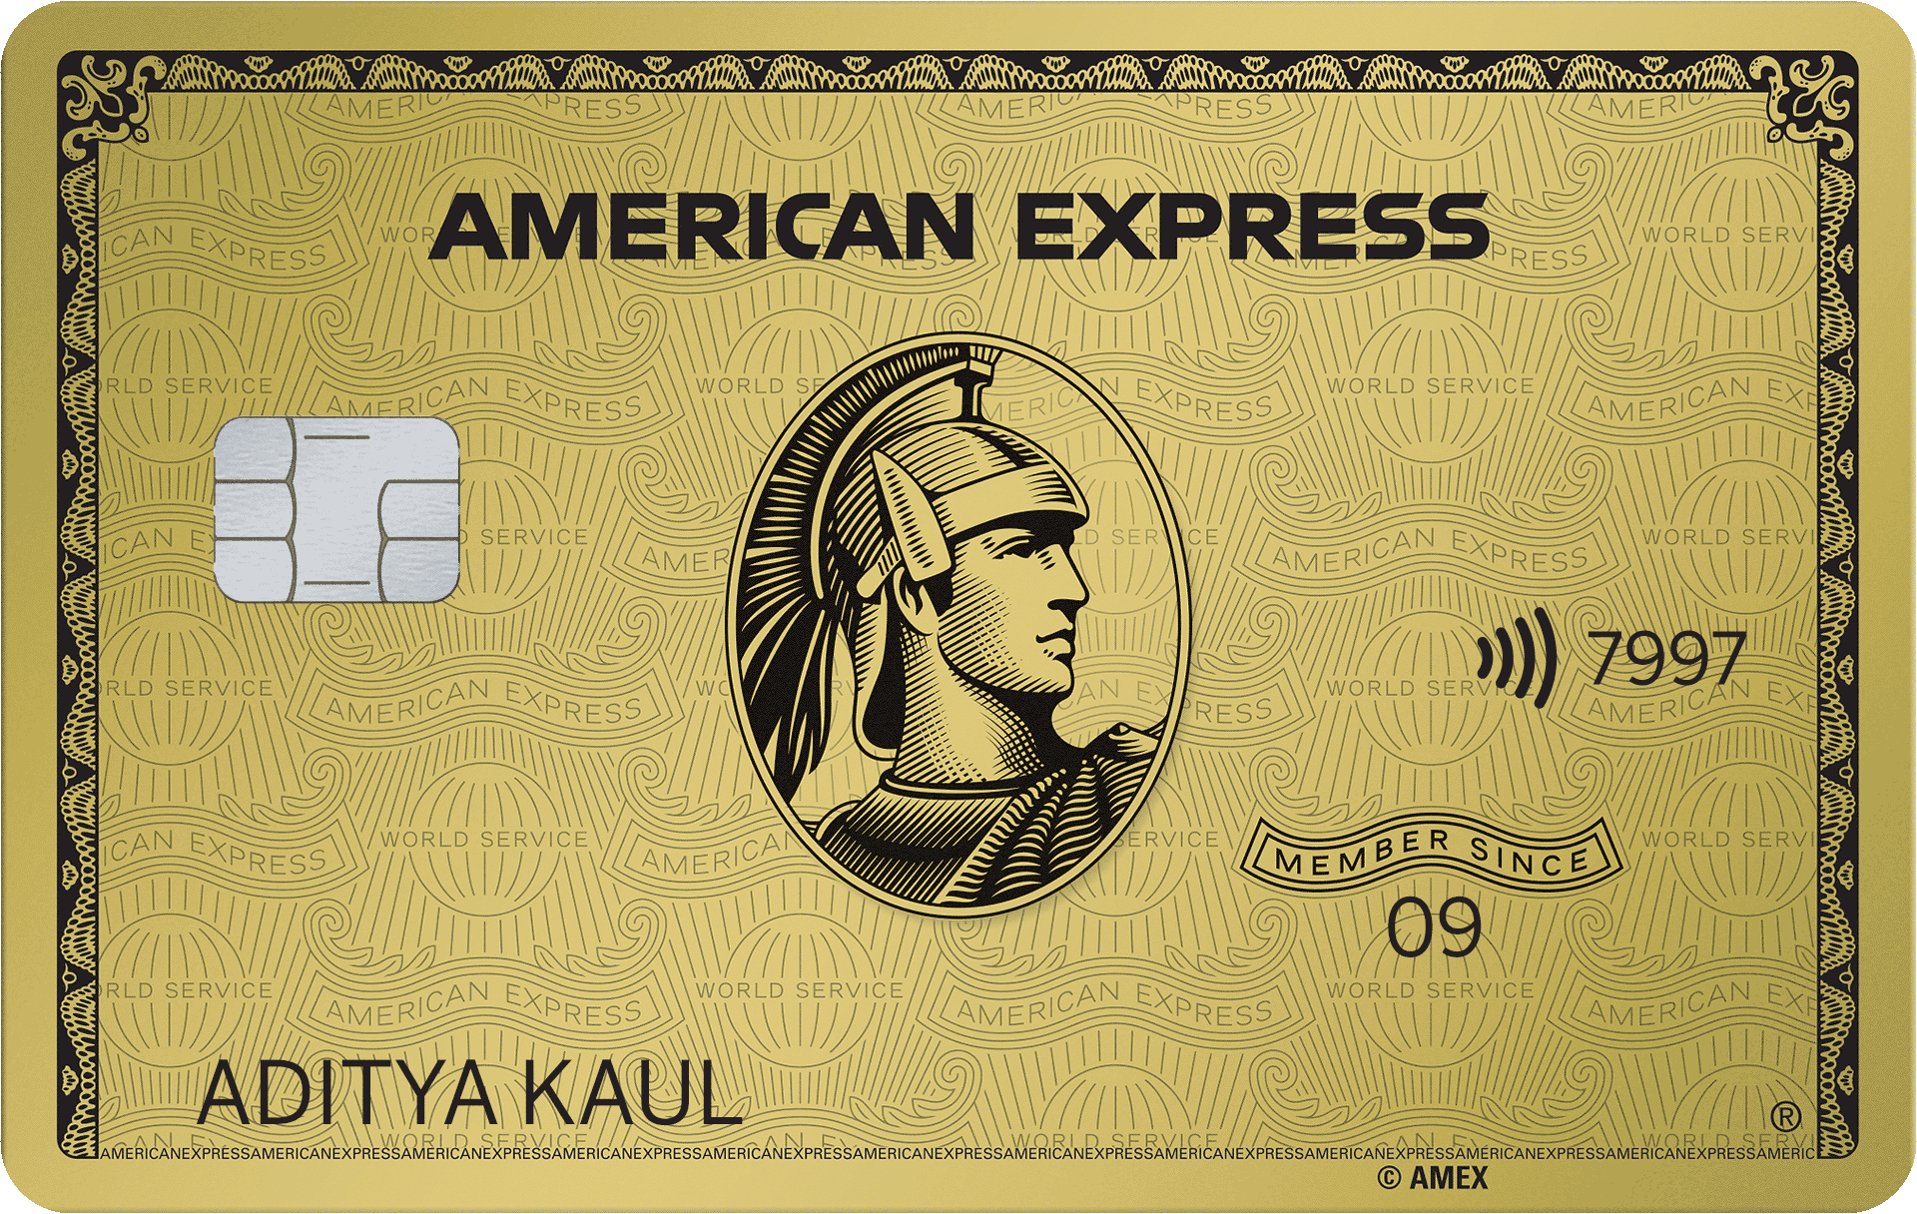

Scenario | Card Number | Brand | Notes
✅ Successful payment | 4242 4242 4242 4242 | Visa | Most commonly used
✅ Successful (debit) | 4000 0566 5566 5556 | Visa (debit)
✅ Mastercard success | 5555 5555 5555 4444 | Mastercard
✅ American Express | 3782 822463 10005 | Amex | 4-digit CVC
✅ Requires CVC check | 4000 0000 0000 0101 | Visa | CVC check passes
Use:
- Any future expiry date (e.g. 12/34)
- Any 3-digit CVC (4 for Amex)
- Any ZIP code

🔐 2️⃣ 3D Secure Authentication (SCA)
Use these when testing authentication flows.
Scenario | Card Number
✅ 3D Secure succeeds | 4000 0027 6000 3184
❌ 3D Secure fails | 4000 0000 0000 3220
🔁 3D Secure required | 4000 0025 0000 3155
These are important if you're testing:
- payment_intent
- confirmCardPayment
- SCA flows (especially in India & EU)

❌ 3️⃣ Payment Failures
Scenario | Card Number
❌ Card declined | 4000 0000 0000 0002
❌ Insufficient funds | 4000 0000 0000 9995
❌ Lost card | 4000 0000 0000 9987
❌ Stolen card | 4000 0000 0000 9979
❌ Expired card | 4000 0000 0000 0069
❌ Incorrect CVC | 4000 0000 0000 0127
❌ Processing error | 4000 0000 0000 0119

⏳ 4️⃣ Payment Requires Action (Delayed Methods)
Scenario | Card Number
⏳ Payment pending | 4000 0000 0000 0341
⏳ Asynchronous confirmation | 4000 0000 0000 3063

🏦 5️⃣ International Cards
Brand | Card Number
Visa (India test works same) | 4242 4242 4242 4242
UnionPay | 6205 5000 0000 0000
Discover | 6011 0000 0000 0004

🧪 6️⃣ For Subscriptions / Recurring Payments
Use:
4242 4242 4242 4242
To test:
- invoice.payment_succeeded
- invoice.payment_failed
- subscription renewals

⚠️ Important Reminders
✔ These only work in test mode
✔ Never use real cards in test mode
✔ Webhooks will still fire for these test payments
✔ You can simulate events using:
stripe trigger payment_intent.succeeded

🎯 Since You're Testing Webhooks
To test your webhook endpoint:
stripe listen --forward-to localhost:5000/api/stripe/webhook
stripe trigger payment_intent.succeeded
That will simulate a real Stripe event.

If you tell me:
- Are you testing one-time payments?
- Or subscriptions?
- Or payment links?
I’ll give you the exact test flow you should run step-by-step 👩‍💻

Perfect 👍 since you’re integrating payments, here are the Razorpay Test Cards you can use in Test Mode.
These only work when:
- You are using Test API Keys
- rzp_test_********
- Dashboard is in Test Mode

💳 1️⃣ Successful Payment Cards
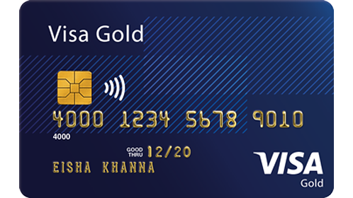
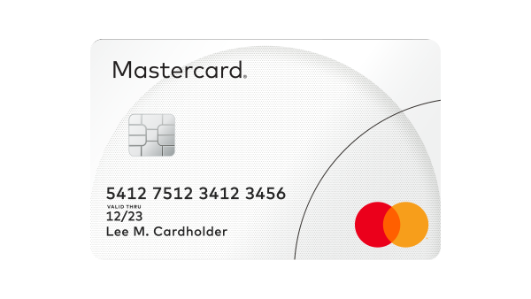

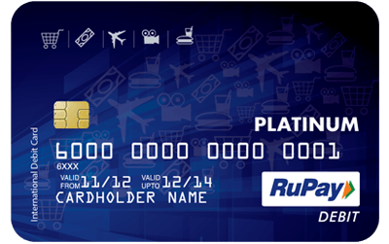
Scenario | Card Number | Brand
✅ Visa Success | 4111 1111 1111 1111 | Visa
✅ Mastercard Success | 5105 1051 0510 5100 | Mastercard
✅ RuPay Success | 6073 8400 0000 0000 | RuPay
Use:
- Any future expiry (e.g. 12/30)
- Any CVV (3 digits)
- Any name
- Any OTP → 123456

🔐 2️⃣ 3D Secure / OTP Testing
In Razorpay test mode:
After entering card details:
- OTP page appears
- Use:
123456
To simulate successful authentication.

❌ 3️⃣ Failed Payments
Scenario | Card Number
❌ Payment Failed | 4000 0000 0000 0002
❌ Insufficient Funds | 4000 0000 0000 9995
❌ Expired Card | 4000 0000 0000 0069
❌ Incorrect CVV | 4000 0000 0000 0127

🏦 4️⃣ Netbanking Test
For Netbanking in Test Mode:
Bank | Behavior
HDFC | Success
ICICI | Success
SBI | Success
Axis | Success
On redirect:
- Click Success or Failure manually (simulation page appears)

📱 5️⃣ UPI Test Payments
Use UPI ID:
success@razorpay
For failure:
failure@razorpay
No real UPI app required in test mode.

🧾 6️⃣ EMI Test
Card | Result
4111 1111 1111 1111 | EMI available
4000 0000 0000 0002 | EMI failure

🧪 7️⃣ Wallet Testing
Wallet | Result
Paytm | Simulated success
PhonePe | Simulated success
Test page lets you choose success/failure.

🚨 Important Differences (Stripe vs Razorpay)
Stripe | Razorpay
4242 4242 4242 4242 | 4111 1111 1111 1111
whsec_ for webhook | Razorpay webhook secret
3D secure test cards | OTP 123456

🎯 For Webhook Testing in Razorpay
You can simulate webhook events from:
Dashboard → Settings → Webhooks → Send Test Event
Common events:
- payment.captured
- payment.failed
- order.paid

Since you're building full stack apps (MERN / ASP.NET / Laravel), tell me:
👉 Are you integrating Razorpay in:
- React frontend?
- Node backend?
- Or ASP.NET Core?
I’ll give you a clean production-ready test checklist so you don’t miss any payment scenario 💻🔥

